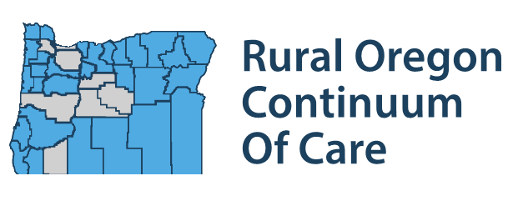

OR-505 BOS CoC/Rural Oregon Continuum of Care (ROCC)
2023 Membership Registration Form

Membership Type: Individual _____ Non-Grantee Organization _______ Grantee Organization _____

Name of Individual or Organization: ____________________________________________________

Address: _____________________________________________________________________________

_____________________________________________________________________________________

Phone: _______________________ Email: ______________________________________________

Contact person (if organization): _______ ______________________________________________

Social Media Site(s): ____________________________________________________________________

Region: (please select one)
 | Region 1: Coos, Curry, Josephine, and Douglas Counties
 | Region 2: Klamath, Lake, Harney, and Malheur Counties
 | Region 3: Baker, Union, Wallowa, and Grant Counties
 | Region 4: Hood River, Wasco, Sherman, Gilliam, Wheeler, Morrow, and Umatilla Counties
 | Region 5: Columbia, Clatsop, Yamhill and Tillamook Counties
 | Region 6: Lincoln, Benton, and Linn Counties

Please check one of the following:
 | Homeless or formerly homeless
 | Community member or provider: (select one of the following)
 | Direct Service, i.e. housing, supportive services
 | Advocacy, i.e. political, peer-to-peer
 | Funder, i.e. small donor, business member, foundation
 | Landlord/potential landlord

Are you interested in serving on the Board of Directors or a Workgroup?
 | Board of Directors
 | Coordinated Entry Workgroup: oversight of CE implementation; policy recommendations
 | HMIS Data Workgroup: data analysis/performance/evaluation/strategic planning
 | Runaway and Homeless Youth (RHY) Workgroup: supporting RHY work; engaging partners
 | Lived Experience Workgroup: advisory; information-sharing/gathering for strategic planning

Please select all service areas that apply to your organization:
__ Affordable Housing Developer
__ Agencies serving survivors of human trafficking
__ Disability Advocates
__ Disability Service Organizations
__ EMS / Crisis response Team
__ Homeless or Formerly Homeless Person
__ Hospital
__ Tribal and tribally Designated Housing Entities
__ Law Enforcement
__ LGBTQ+ Advocates
__ LGBTQ+ Service Organization
__ Local Government
__ Law enforcement
__ Mental Health Advocates
__ Mental Health Service Organizations
__ Organizations led by and serving Black, Brown, Indigenous and other people of color
__ Organizations led by and serving LGBTQ+ persons
__ Organizations led by and serving people with disabilities
__ Other homeless subpopulation advocates
__ Public Housing Authorities
__ School Administrators / Homeless Liaisons
__ State Domestic Violence Coalition
__ State Sexual Assault Coalition
__ Street Outreach Teams
__ Substance Abuse Advocates
__ Substance Abuse Service Organizations
__ Victim Service Providers
__ Domestic Violence Advocates
__ Other Victim Service Organizations
__ Youth Advocates
__Youth Homeless Organizations
__ Youth Service Providers

If you intend to apply for CoC funding, please attach:
__ Board Roster with Homeless or Formerly Homeless Person Designation
__ Current Strategic Plan
__ Equity Statement
I understand that, as a Direct Service provider I am required to follow the Continuum of Care guidelines for Coordinated Entry, Rapid Rehousing, Permanent Supportive Housing and HMIS.

______________________________________________ ________________________
Signature Date

